<Key Store Architectural Analysis>
Security Classification: | <Security Classification> | Team/Department: | <Security Team >
Document Reference: | <SXX.XXXnnn.nnn> | Author(s): | <Leon Clarke>
Status: | <Issued> | Owner(s): | <Security Team>
Version: | <1.0> | Approver(s) | <Name>

Introduction

Purpose and Scope
This is the architectural analysis for the key manager. It is intended to be read by anyone who is either using or maintaining the file key manager or writing other stores to the same API (for instance WIMs or other hardware stores). It explains its architecture and the motivation behind it.

Purpose of the file key manager and the key manager API
The key store API is an API in the Crypto Token framework that provides access to private keys. It is designed as an abstraction of a hardware key store, where the keys are kept securely within the store.
The software key store is an implementation of this API that does not rely on special hardware. It stores the keys in an encrypted file in the store’s private data area. The passphrase for the encryption is not stored on the device, but the user is asked for it whenever it is needed. Thus the private keys are encrypted both by password-based encryption and by the security offered by platform security’s data caging. Obviously, tamper resistant hardware storage, such as a WIM, would offer even greater security.

Ownership and Usership
A concern with general-purpose key manager is chosen protocol attacks. The meaning of a signing operation can be used to assert identity or to sign a particular piece of data depending on the protocol in use. Also, the user must often be informed of how the key is being used, but the key store can’t do this without knowing the meaning of the signing operation. Examples of attacks we are trying to prevent would be a malicious application purporting to do a SSL handshake while in fact forging a signed S/MIME message, or doing a SSL handshake to a bank and then performing operations on the user’s bank account without their consent.
Our general approach to solving this problem is to enforce the ownership of keys by particular applications; this means that a malicious application would not be able to use another application’s keys, and that applications are responsible for informing the user of how private keys are being used. Applications will be identified by the UID of the process, as this is easily enforced by platform security. However, some applications may be implemented as several processes. To allow for this, we have extended the concept of key owners by adding key users. An owner created a key and can do anything with it, including deleting it and assigning users. A user can use the key for cryptographic operations, but can’t delete the key or change its usership.
When listing keys, it will be possible to only list keys owned by a particular owner. All applications should use this, to prevent malicious applications ‘giving them’ insecure keys.
An interesting variant on this problem is Java. If Java wanted to support SSL client authentication, this could be used by MIDLets, Applets and potentially other classes of server code. Applets presumably should use the same keys as the web browser that they seem to be part of. There might be a different set of keys for MIDlets and so on. The ownership/usership scheme can handle this use case, as Java can work out what class of application it is running, and restrict its keys to ones owned by that application. (When running applets, only the browser’s keys would be considered)
This concept is exposed in the API, but may be mapped onto other stores in different ways. For instance, a WIM does not support the storage of this ownership and usership information, but its keys are to be used for defined purposes (WTLS client authentication and WMLScript SignText.) A WIM could model the ownership/usership information by assuming a static set of owners/users for each kind of key, or it could have some sort of control panel to define how keys should be used.
The probable way of using this is to have a key management UI for every application that uses private keys. This UI would own all the keys in that application, and would assign any associated processes as other users of the keys. This idiom means there is no role for a central key manager UI as the ownership rules would prevent it from managing the keys. An alternative idiom is to have all keys owned by a central key manager UI, which assigns usership to the right application. The differences between these 2 idioms are purely at UI level.
There will be an option on the ‘List keys’ API to list all keys, including ones not usable by the current application. This will be provided in order to allow a program that lists all keys on the device, together with their owners. Such an application could be used by a helpdesk to help a user delete all their keys when they’ve completely forgotten their passphrase. (In this situation, all keys must be deleted at which point the old passphrase is essentially deleted with them. The application to list all keys helps find all the keys, as they must be deleted from within their owning application.)
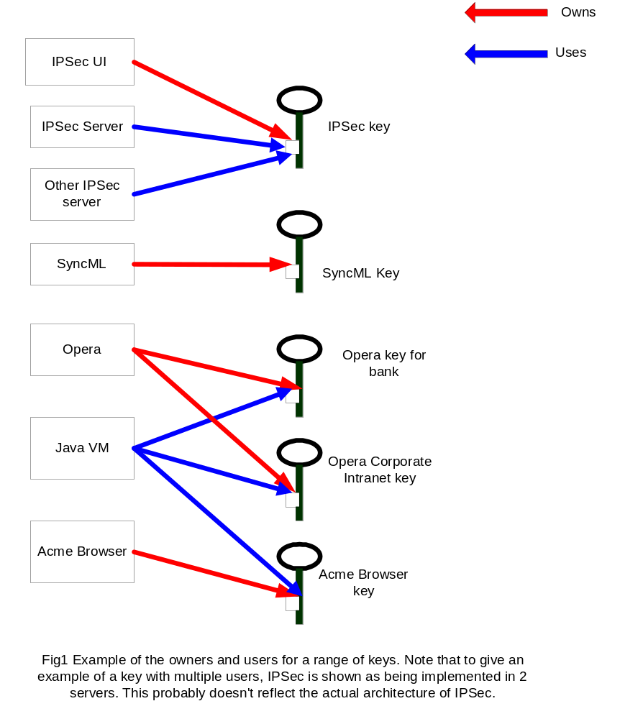

The API
The API will be defined in more detail in API documentation, which should be referred to by anyone who actually needs to call it. This section will describe the API in broad architectural terms.
There are 2 parts of a typical application that will need key management APIs, a UI responsible for creating, deleting and managing keys, and an ‘engine’ part that actually uses the keys. The API functionality can be grouped into things needed by both, by the UI and by the engine.
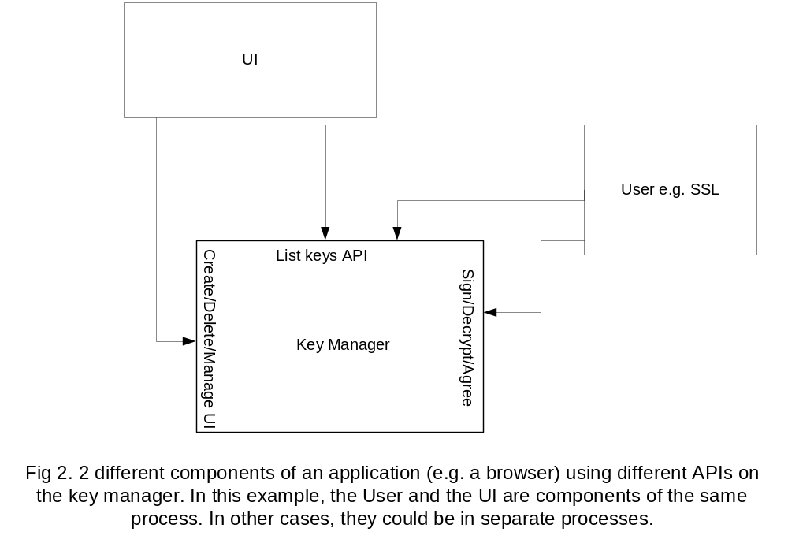

List Keys API
- There will be list functionality, which will be based on the current key store API. It will be extended to allow filtering based on the key owner, and to allow keys not usable by the current application to be listed.
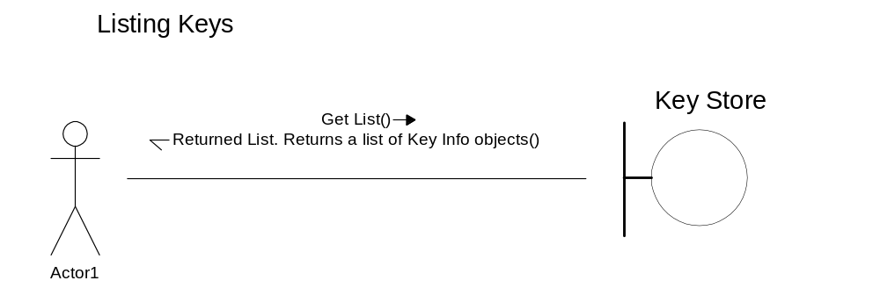

APIs used by the Owner
- Create a key
- Delete a key
- Import a key
- Export a key (if allowed)
- Set the users for a key
- Set the passphrase caching timeout. (Valid values include 0, which means the passphrase is asked for every time)
- Manage authentication objects via the existing authentication object API.
Keys will be imported/exported in PKCS#8 format, optionally encrypted with PKCS#5. Authentication objects (normally passphrases) are managed according to the existing Authentication Object API. This has 2 advantages; the user of a key doesn’t need to be trusted with its passphrase as the passphrase never appears in the API, and anyone wishing to implement a key manager using some other authentication object such as biometrics is able to do so within the existing API.

APIs used by the user
These APIs will be grouped into classes representing an ‘opened’ key pair. Separate classes will be defined for RSA keys, DSA keys, DH keys and non-repudiation keys. (The RSA and DSA ones apply only to repudiable keys) The general style of operation will be to ‘open’ a key to return an object which has methods for the supported cryptographic operations, then to call these methods. Each will support the following operations:
- RSA supports Sign and Decrypt
- DSA supports Sign
- DH supports Agree Key
- The non-repudiation key class supports SignText
In addition, the key store will have an API to export the public key of a key pair.
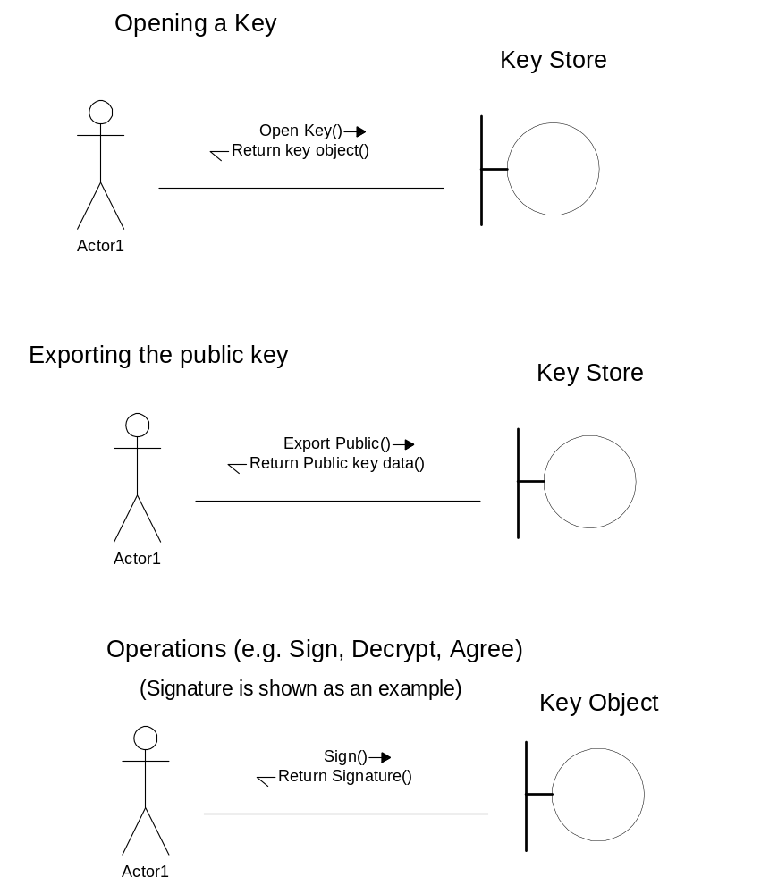

Passphrase issues in the API
Passphrase handling will be via the existing Authentication Object and secure dialog APIs. Some extensions are needed to handle the use of decrypt keys as an unblocking passphrase for the file cert store. The usual concept of an unblocking passphrase (or PIN, in WIM terminology) is that once a passphrase has been entered incorrectly for some number of times (typically 3), the key will become ‘blocked’ and an ‘unblocking PIN’ must be entered in order to use the key again. Typically, the user would have to contact the WIM supplier to get the unblocking PIN. This concept is not applicable to a password-based store, especialy as there is no central authority to get the unblock passphrase from. However, there is a similar concept in which the user can use the decrypt key as an emergency way of recovering from a forgotten passphrase. When a passphrase is chosen, the derived decrypt key will be displayed to the user as the unblock passphrase. (This may be a 32 digit hex number, although on phone-sized devices an even longer decimal number may be more convenient). The user can write this down and keep it in a very safe place, and use it to change their passphrase when it is forgotten.
To support this usage, some additions to the key store API are needed. These are:
- The Unblock PIN dialog will take a new flag which indicates if it is reasonable to enter the unblock PIN without being able to see what you’re typing. (If the PIN is a 32 digit hex number, it will be hard to type correctly without feedback, and anyone shoulder-surfing can just read the piece of paper that the user is copying it off in the first place)
- There will be a new secure dialog that displays the unlocking PIN after changing a PIN.
- The ‘unblock PIN’ dialog will take a new argument that specifies whether the unblocking PIN should be displayed to the user as they type. (The user will probably make a mistake if entering a 32 digit hex number blind, and any shoulder-surfer can just read the piece of paper that the user is copying from)
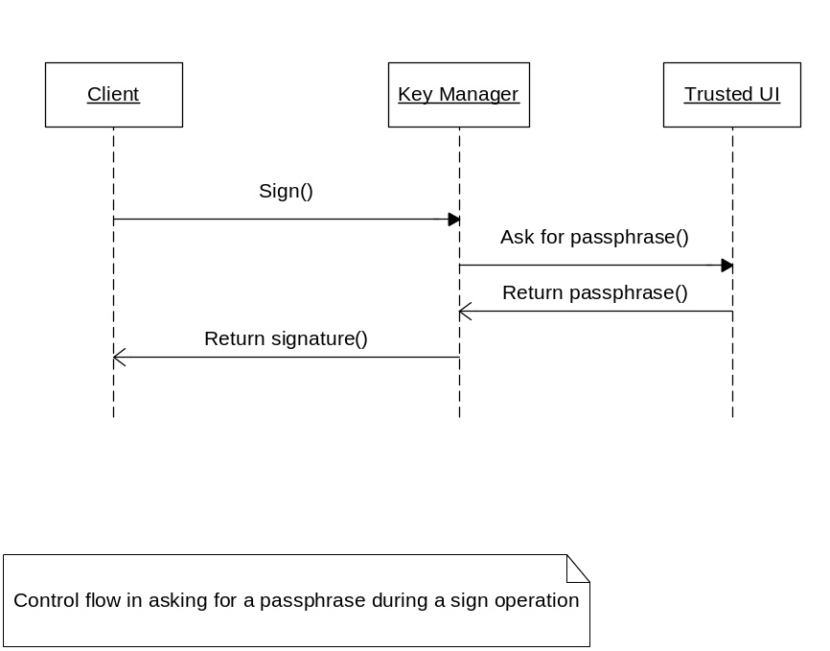

The implementation of the file key store

Summary
The key store is implemented in a client/server manner, and uses the same server process as the certificate store for efficiency. The server process has Trusted UI capability, which is used to confirm operations with the user.

Encryption and key storage.
Keys are stored in a permanent stream store, each key will be stored as a separate stream, in the format of a PKCS#5 encrypted PKCS#8 object. A standard format is used for the encryption to increase confidence in its security. This is then stored in a stream store to provide an easy and efficient way of storing the keys. The commit/revert capabilities of the persistent store will be used to ensure that the store is always consistent.
PKCS#5 is a standard for deriving keys from a passphrase. To protect against dictionary based attacks, it uses a large number of iterations of the basic algorithm (1000 is reccomended) to make the process of deriving each key quite slow. (The time will be acceptable when deriving one, but unacceptable when deriving a dictionary worth). To protect against someone building a re-usable derived dictionary, for instance by organising a distributed effort to generate the decrypt keys corresponding to every word in a dictionary, the key is merged with a ‘salt’, a random string that is stored in the clear along with the encrypted object.
Encryption will be done using AES. All keys encrypted with the same passphrase will share a salt, so that the decryption key can be cached rather than the passphrase (predominantly for efficiency reasons, although this is arguably more secure and the increased efficiency allows higher iteration counts). The salt will be changed whenever the passphrase is.
The root stream of the store will contain an index of all the keys. This will contain any singleton information, and a list of the IDs of streams containing the information returned by the list operation. These streams will in turn contain a pointer to another stream containing the PKCS#5/PKCS#8 objects corresponding to each key.
The encryption will be implemented via the secure stream classes. It is possible these won’t actually use the PKCS#5 format for data, to reduce dependencies on ASN.1, but it will use the PKCS#5 key generation algorithm.
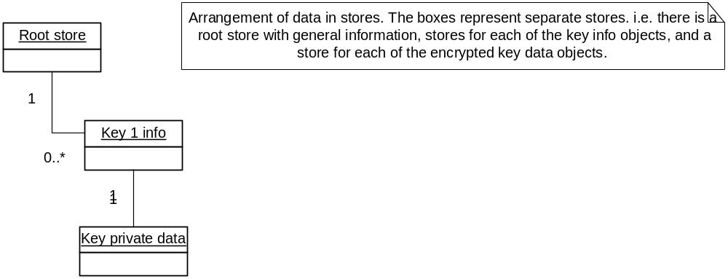

Passphrase management
Non-repudiation keys will ask for the passphrase on every occasion, and will present the text to be signed via a trusted UI.
All other keys will all share a single passphrase.
Passphrases will be managed via the authentication object interface.
For keys other than non-repudiation keys, the passphrase will be cached for a period of time, on a per-owner basis. That is to say, when a passphrase is entered, all keys owned by the same owner will be unlocked until the passphrase timeout expires. Keys owned by a different owner (to the owner of the key whose use provoked the passphrase dialog) will remain ‘locked’, and will still provoke a passphrase dialog.
The re-lock operation re-locks all keys owned by the calling process.

Client/Server issues
Obviously, the key goal in making this client/server is that private keys never leave the server. Thus all private key operations must take place server-side.
The client/server architecture should be designed to assist future WIM implementations of the key management API. This means that the client/server interaction should mirror interaction with the WIM, in order to maximise confidence that the right calls are asynchronous. That is to say, whenever possible an operation that involves a separate call to the WIM should involve a client/server call. This will increase confidence that all necessary functions are asynchronous.
In addition, it should be structured to allow the client/server code to be re-used by other client/server key managers such as WIMs.

Further Information

People
Role | Person / People
Contributors | Leon Clarke
Reviewers
Distribution

References
No. | Document Reference | Version | Description
[1] | PKCS#5 | 2 | http://www.rsasecurity.com/rsalabs/pkcs/pkcs-5/
[2] | PKCS#15 | 1.1 | http://www.rsasecurity.com/rsalabs/pkcs/pkcs-15/
[3] | PKCS#8 | 1.2 | http://www.rsasecurity.com/rsalabs/pkcs/pkcs-8/index.html
If you select the document description, then Ctrl+k you can input the URL or file location of the reference document, thus making it easier for the reader to locate the document.

Open Issues
The following issues need to be resolved before this document is completed:

Glossary
The following technical terms and abbreviations are used within this document.
Term | Definition
Private key | If you don’t know what this means, read an introduction to cryptography and then come back.
Non-repudiation key | A key which can be used to sign things in the same way as hand-written signatures are used. In this application, non-repudiation keys will be used via the WMLScript and ECMAScript SignText functions
Repudiable key | Symbian term for a key that’s not a non-repudiation key
WMLScript | A Scripting standard defined by the WAP forum, based on ECMAScript
ECMAScript | A standardisation of the web scripting language normally known as JavaScript
WIM | A Wireless Identity Module. A standard for cryptographic smartcards similar in size to GSM SIMs defined by the WAP Forum
WAP Forum | http://www.wapforum.org/
IPSec | A very general protocol for providing security on the iterne, used for Virtual Private Networks and similar applications.
SSL | A protocol for providing security on top of a TCP socket, used by secure web browsing (https) and other applications such as secure downloading of email.
ASN.1 | A data format used by many cryptographic standards. (More exactly, the DER data format, which is a representation of ASN.1 is used in many cryptographic standards)

Document History
Date | Version | Status | Description
14-06-2002 | 1.0 | Issued | Issued
11-06-2002 | 0.3 | Draft | Updates following review comments
 | 0.1 | Draft | First draft based on SGL.PPS001.500 Lightweight Document Template Rev 6.0

